Create Inbox Rules in PowerShell
Posted: May 26, 2017/Under: Microsoft Exchange, PowerShell/By: jay c
Let’s say you want to create in Inbox Rule and you don’t want to (or can’t) use Outlook to do it. Who cares why, right? You just don’t.
$ReasonsWhy = “Not Relevant”
You can use the New-InboxRule to move, copy, delete, forward, classify…whatever…newly received messages, just like you can if you created the rule through Outlook’s wizard. You can’t do quite everything in PowerShell that can be done via the GUI. For example, you can’t permanently delete the message, bypassing the Deleted Items folder and sending it directly to the dumpster. But you can delete it and mark it as “read” which is almost as good.
Open PowerShell and connect to your Exchange system (or open the Exchange Management Shell), and run New-InboxRule with all of the parameters you want from the long list you can find here. These are some of the options you are most likely to want:
Parameter | More info
Mailbox | The name, alias, DN, etc., of the mailbox in which you want to create the rule.
Name | The name of the Inbox Rule.
SubjectContainsWords | Words to look for in the message subject.
BodyContainsWords | Words to look for in the message body.
SubjectOrBodyContainsWords | Words to look for in both the message subject and body.
From | The sender’s email address.
DeleteMessage | $True or $False.
MoveToFolder | Move the message to this folder.
StopProcessingRules | $True or $False.
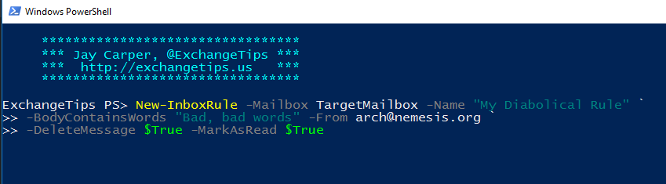

Example:

On mailbox for tbock@mltaikins.com
Set Rule
New-InboxRule -Mailbox tbock@mltaikins.com -Name “Block no reply Linkedin” -from notifications-noreply@linkedin.com -DeleteMessage $True

View Rules
Get-inboxRule -mailbox tbock@mltaikins.com

Delete Rules
Remove-inboxRule -identity "Block no reply Linkedin" -mailbox tbock@mltaikins.com

